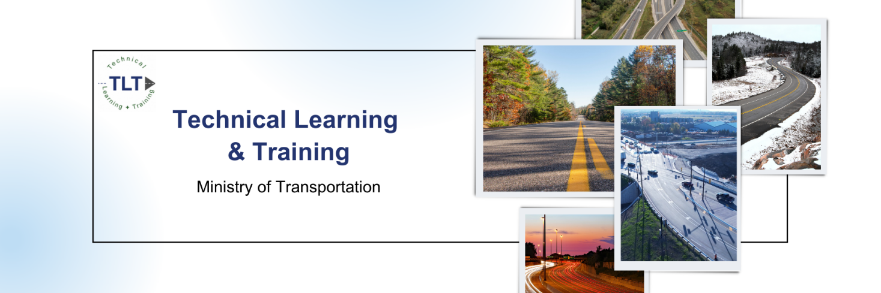
TLT 131 – Advanced Issues Resolution: Application

Deadline for application submission is November 17th, 2023, at 11:59pm.

Division Services Office
Transportation Infrastructure Management Division
2023-24

Produced by
The Ontario Ministry of Transportation
© 2019 Queen's Printer for Ontario

Requirements
To participate in TLT 131 Advanced Issues Resolution you must complete this application fully. The information provided will be verified before you are admitted into the course.
The minimal requirements to attend TLT 131 are:
- A completed post-secondary degree in Engineering, and a PEO designation
- Graduated from the community college system in Civil Engineering or Construction Technology, and an RCCA designation in good standing with OACETT
- Current employee with a RAQS certified company
- All require government issued photo identification

Please note: this training is not provided for persons employed in the contracting industry

Name

Name as it appears on your Government Photo ID and/or certifications |  |  |  |  |  | Commonly used name

Proof of Identity
As proof of your identity, you are required to display an official Government photo ID at the beginning of your examination. Acceptable pieces of ID include:
- Driver’s Licence
- Health Card (With Photo)
- Passport
- Other acceptable forms of Government photo ID
If you do not provide valid ID you will not be permitted to write the examination.

Current Employment
Company Name |  |  |  |  |  | Company Address
Title or Position |  |  |  |  |  | Personal Email Address
Business Phone |  |  |  |  |  | Is this Company RAQS Certified?

Payment

The registration fee for TLT 131 Advanced Issues Resolution is $320.00. Please indicate below the name, email address, and phone number for the individual who will be paying your registration fee should your application be accepted.

Name of Payee

Email Address |  |  |  |  | Phone Number

Experience Record
Company Name | Contract # | Title/ Position |  |  |  |  |  | Start Date | End Date
Professional References (in relation to the experience noted above)
Name |  |  | Phone Number |  |  |  | Email

PEO and OACETT
Are you PEO certified? Are you OACETT certified with an RCCA?

Preferred Delivery Days – Please highlight one (This does not guarantee a spot on the date of your preference):
- April 8th & 9th 2024
- April 10th & 11th 2024

*Please note the course will be delivered in person, the location will be announced prior to registration fees being collected*

No Show Policy
If you are admitted into a TLT 131 Advanced Issues Resolution session and cannot attend the course for ALL the required time, you MUST notify TLT@ontario.ca more that 72 hours before the beginning of the course. If you do not provide proper notice, you will not be entitled to attend future sessions of Advanced Issues Resolution and you will not be able to receive a refund. Successful completion relies on full attendance for the entire session and passing the examination.

Declaration
I Insert Name accept the requirements indicated in order to both gain admittance and complete the Advanced Issues Resolution course. By signing this application, I declare all provided information to be true and verifiable. If any information provided is found to be untrue, I accept that I will forfeit my eligibility to attend future sessions of Advanced Issues Resolution.
Signature |  |  |  |  |  |  | Date
Please submit to TLT@ontario.ca once completed.

